28.03.2018



**MIDDLE EAST TECHNICAL UNIVERSITY**

DEPARTMENT OF ELECTRICAL AND ELECTRONICS ENGINEERING

**EE 564** Project #1

***INDUCTANCE AND TRANSFORMER MODELING***

GÖKHAN ÇAKAL – **2332120**

Contents

1. Introduction 2

2. Inductor Design 3

1. Analytical Calculations 5

1. Homogenous and Linear Core 5

2. Non-Homogenous and Linear Core 5

3. Homogenous and Non-Linear Core 6

4. Non-Homogenous and Non-Linear Core 6

5. Air Gapped Homogenous and Linear Core 7

6. Air Gapped Core with Fringing Effect 8

2. Finite Element Analysis 9

1. Linear Core 10

2. Non-Linear Core 12

3. Non-Linear Gapped Core 13

3. Discussion 15

3. Transformer Design 17

Results 20

4. Conclusion 22

5. References 23

# Introduction

In this report, design of inductor and single phase transformer will be studied. Report consists of two main sections, inductor design and transformer design. In the inductor design part, a toroid shaped inductor will be selected. Different core properties will be also investigated. Linear core and non-linear core will be compared. Also, homogenous and non-homogenous core types will be investigated. The inductors with these different properties first calculated analytically and analytical results will be verified using FEM. Lastly, effect of air gap in toroid inductor will be investigated.

In second part of the report, single phase transformer will be designed. Design procedure will be studied in details and a design guide will be provided. In the transformer, effect of different parameters on efficiency and cost will be investigated such as number of turns, core types, laminations etc. Lastly, an optimum solution will be provided with maximum efficiency and lowest cost.

# Inductor Design

In the design, a toroid inductor core from Magnetics with part number 0077739A7 are chosen. Its properties are summarized in the Table 1.

Table 1: Properties of Chosen Inductor Core

|  |  |
| --- | --- |
| Property | Value |
| Core Type | Kool Mu |
| Kool Mu Permeability | 90 |
| Inductance Factor (AL) | 306 (nH/turns2) |
| Outer Diameter (OD) | 74.1 mm |
| Inner Diameter (ID) | 45.3 mm |
| Height (HT) | 35 mm |
| Cross Section Area (Ae) | 497 mm2 |
| Path Length (Le) | 184 mm |

With given parameters of the given core, first B-H characteristics are obtained. Also, relative permeability vs H characteristics are obtained. This can be seen in following figures.

 

Figure 1: B-H Characteristics of Selected Core

 

Figure 2: Permeability vs H characteristics

Note that, in figures above, same characteristics are plotted with different scales of H. With this characteristics, we can determine operation point of the core. We see that core has linear behavior up to 0.2 T. Therefore, we can choose as linear operation point at 0.1636 T. Accordingly, number of turns are found as follows. To find number of turns, current of 5 A assumption is made.

$$H*L_{e}=15.5*18.4=285.2 A*turns$$

$$B=0.1636 T$$

$$µ=83.82$$

$$N=57 turns$$

$$i=5 A$$

## Analytical Calculations

### Homogenous and Linear Core

After determining number of turns of our inductor, we can easily find inductance of linear and homogenous core by finding reluctance of the core. In linear core, core has constant permeability and core is not saturated. This permeability value is obtained from datasheet of the given core and found as 83.82 as relative permeability. Additionally, homogenous core means that flux distribution in the core is homogenous. Every point inside of the core has the same magnetic field density. In reality, inner side of the core has shorter length and therefore, flux density is higher in inner side of the core as we will see in following sections. First, let’s find inductance for linear and homogenous core.

In this calculation, note that µr has 83.82 relative permeability value. At this operation point, core shows linear characteristics.

### Non-Homogenous and Linear Core

Now, core is no longer homogenous and it is composed of many discrete parts. In Matlab environment, core is divided into many parts axially. Each part has different length and therefore each part has different reluctance and inductance. More accurate results are obtained when core is divided as many parts as possible. First, reluctance of each part is found and then equivalent reluctance is found. Using this, inductance is found as follows.

$$\frac{1}{R_{eq}}=\frac{1}{R_{1}}+\frac{1}{R_{2}}+\frac{1}{R_{3}}+...+\frac{1}{R_{n}}$$

$$L_{eq}=\frac{N^{2}}{R_{eq}}$$

$L_{eq}=$ 0.94 mH

It is observed that 3% more inductance is calculated in non-homogenous linear core. This is more realistic value and this calculation can be used in practical applications.

### Homogenous and Non-Linear Core

In this part, we will investigate the effect of non-linear core and saturation. DC current is increased by 50% and therefore total ampere-turn increases. Since we have now non-linear core, relative permeability is decreased with increasing ampere-turns. This relation can be seen in Figure 2. With this operation point, we have following results.

$$i=7.5 A$$

$$N=57 turns$$

$$N*i=427.5 At$$

$$H=\frac{N*i}{l_{mean}}=22.79 \frac{At}{cm}$$

$$µ_{r}=73.97$$

$$B=0.23 T$$

$$R=\frac{l_{mean}}{µ_{r}*µ_{0}*A}=4.06*{10}^{6} \frac{1}{H}$$

$$L=\frac{N^{2}}{R}=0.8 mH$$

This result shows us that in non-linear core, inductance reduces with increasing current. This is due to the decrease in relative permeability of the core. In linear core, we would not observe decrease in inductance with increasing current. Now, let’s see the results in non-homogenous, non-linear core.

### Non-Homogenous and Non-Linear Core

Like in the non-homogenous linear case, we divide core into small pieces and reluctance of each piece is calculated separately. Then, equivalent reluctance is calculated from these individual reluctances. From equivalent reluctance, inductance of the core is calculated. Results can be seen below.

$$\frac{1}{R_{eq}}=\frac{1}{R_{1}}+\frac{1}{R_{2}}+\frac{1}{R_{3}}+...+\frac{1}{R_{n}}$$

$$L_{eq}=\frac{N^{2}}{R_{eq}}$$

$L_{eq}=$ 0.83 mH

With this results, 3.6% more inductance is calculated compared to homogenous and non-linear core. The results of four case are summarized in following table.

Table 2: Inductance Values for Different Cases

|  |  |  |
| --- | --- | --- |
|  | **Linear**  **(At=285.2)** | **Non-linear**  **(At=427.5)** |
| **Homogenous** | 0.91 mH | 0.80 mH |
| **Non-homogenous** | 0.94 mH | 0.83 mH |

### Air Gapped Homogenous and Linear Core

In this part, we will create 2 mm air gap in our core and calculate the inductance again. We will neglect fringing in the air gap. Here, we assumed homogenous and linear core. As calculated in previous parts, we have 83.82 relative permeability for linear core and this is constant. To calculate the inductance for this case, first, reluctance of the system should be calculated. Reluctance is simply sum of reluctance of gap and core. Then, inductance can be calculated easily.

Here, we observed that by introducing air gap at the core, total reluctance is increased and therefore inductance is decreased. With this core, we can store more magnetic energy compared to previous cores.

### Air Gapped Core with Fringing Effect

To include the effect of fringing, we can use proposed method in Mohan [1]. Here, air gap cross section area is calculated with extension of g/2 as can be seen below.

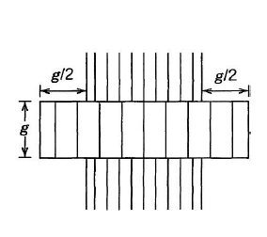

Figure 3: Fringing Effect

With this adjustment, air gap cross section area is calculated as follows.

Here, effective air gap cross section area is increased and reluctance is decreased. With the decrease in overall reluctance of the system, it is observed that inductance is increased with including the effect of fringing flux.

## Finite Element Analysis

In this part of the project, we will verify analytical results with finite element analysis. FEM study is conducted on Maxwell software. Toroid core is built as 3D model. Model can be seen in figure below.

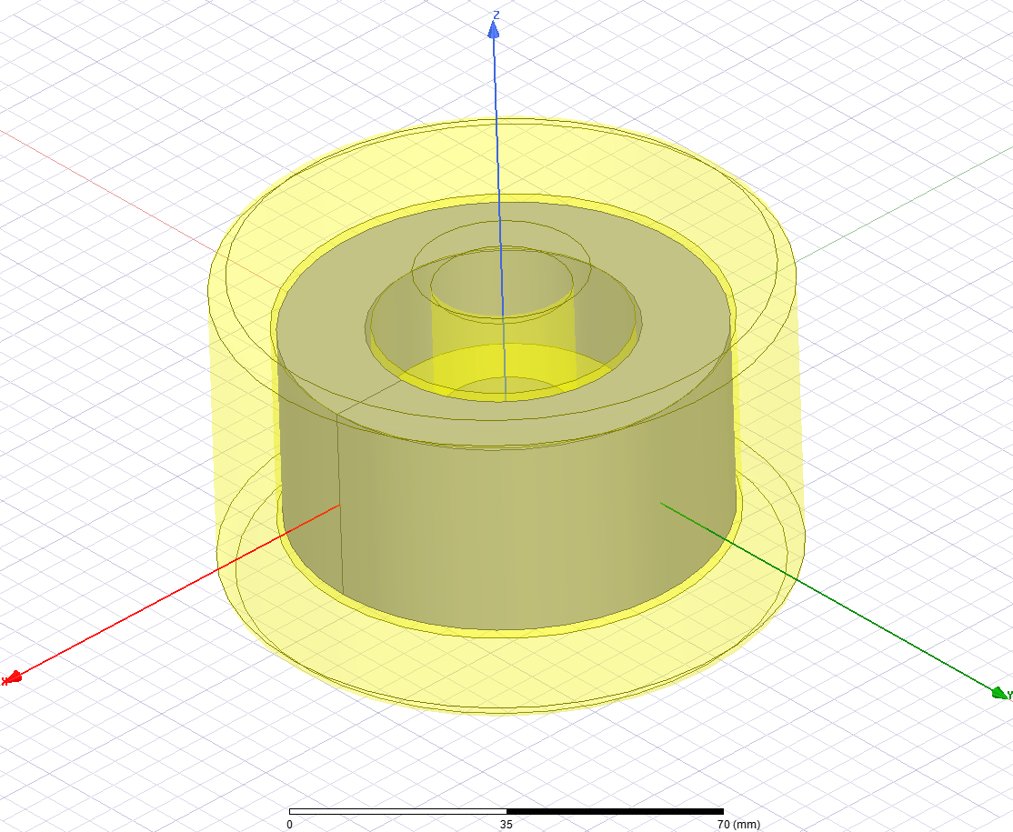

Figure 4: 3D Toroid Inductor Model

In this model, yellow transparent part represents coils wound around toroid core. Core is gray part in figure above.

### Linear Core

In this part, core is assumed to be linear and it has constant relative permeability of 83.82 as used in analytical part. Turns number is 57 and 5 A of current is flowing through coils. Flux density distributions of the core can be seen in following figure.

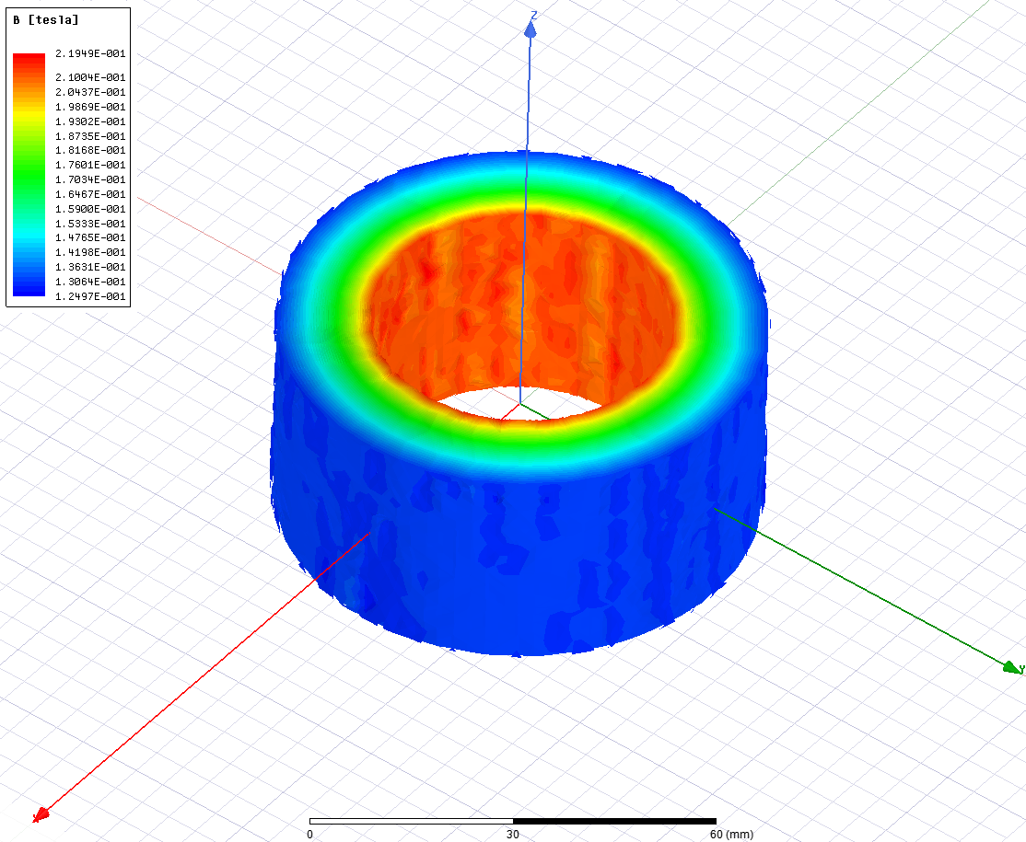

Figure 5: Flux Density Distribution of the Core

As can be seen in the figure, flux density is higher at inner side of the core compared to outer side of the core. This can be explained from the flux path. Inner side of the core has shorter flux path and thus less reluctance. This means that flux density is higher at that regions. On the contrary, outer side of the core has higher reluctance and therefore has less magnetic field density.

To calculate inductance of the linear core, matrix equation is assigned in Maxwell software and inductance is calculated as follows.



Figure 6: Linear Core Inductance Calculation (uH)

Analytically, inductance is calculated as 0.94 mH and in FEM, inductance is calculated as 0.95 mH. There exist 1% difference in calculation. FEM has higher reluctance. This small difference may be caused from leakage flux, which is ignored in analytical calculations. Also meshing in FEM effects the results.

To calculate leakage inductance, we can use stored magnetic energy in air and coils. Main flux travels in core and flux travelling in air composes leakage flux. We have following relation between current and magnetic energy.

From FEM analysis, stored energies in air can be seen as follows.

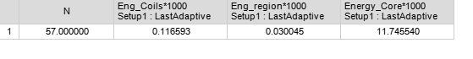

Figure 7: Energies Stored in the Model (mJoule)

In the figure, it is observed that core has 11.75 mJoule of stored energy while air and coils have stored energy of 0.1466 mJoule of stored energy. From here, we can calculate both inductance and leakage inductance.

Here, it is observed that leakage inductance is 1.3% of actual inductance. By this method, we also verified inductance calculation in Figure 6.

### Non-Linear Core

In this part, we will investigate the effect of non-linear core. To do this, we exported BH characteristics of selected core to Maxwell. In the design, we increased the current by 50%. Since we have non-linear core, we expect less inductance in the system. Magnetic field density distribution can be seen in following figure.

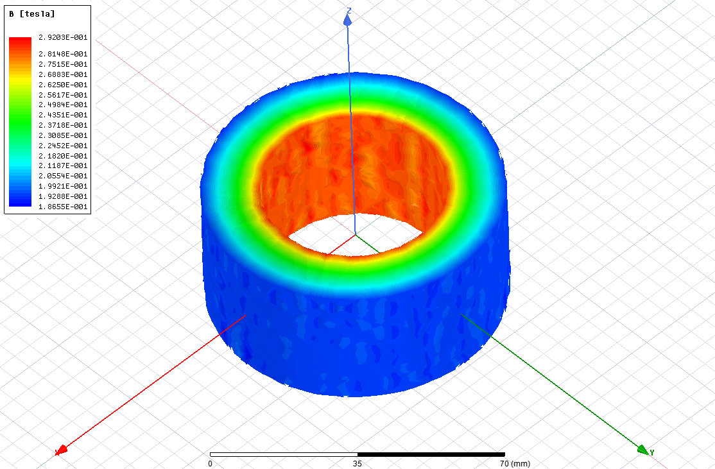

Figure 6: Magnetic Field Distribution

Similar to linear case, we have less magnetic field density at outer sides of the core. Now, let’s find inductance of the inductor using FEM.



Figure 7: Inductance of the Non-linear Core (mH)

In FEM, we get inductance as 0.89 mH. Analytically, we found it as 0.83 mH. There exists 5% difference between FEM and analytical results. This difference can be result from leakage flux. We can calculate leakage flux in Maxwell using stored energy in air as follows.



Figure 8: Energies Stored in the Model (mJoule)

In the results, we observe that we have same leakage inductance with linear case and inductance is decreased. With stored energy method, we obtained more accurate results compared to Figure 7. We have same result with analytical calculation.

Also, it is important to note that we have more stored energy in non-linear core compared to linear core.

### Non-Linear Gapped Core

Now, we have 2 mm of air gap in our core and we will investigate the effect of this core on inductance. Also, fringing flux will be observed in this design. In FEM, following model is constructed with 2 mm of air gap.

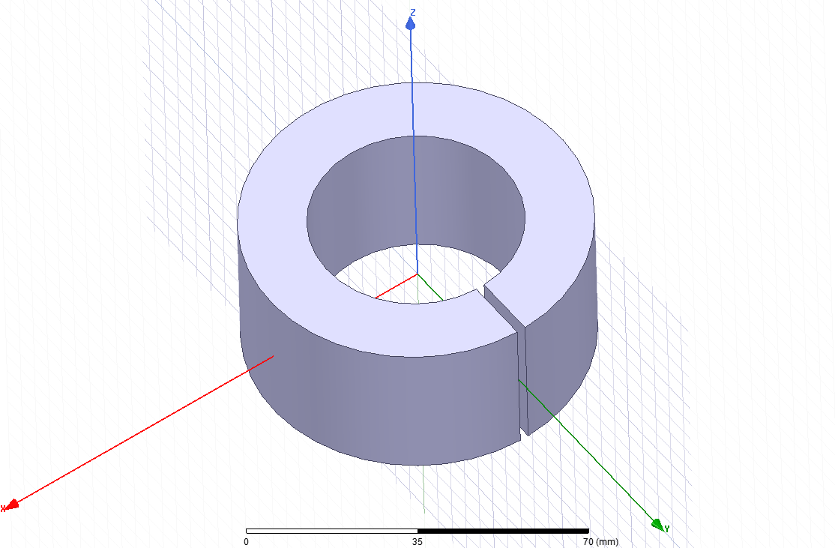

Figure 9: Air Gapped Toroid Inductor

Now, let’s first observe the effect of fringing flux. In 2D design, fringing flux can be seen easier. In 2D model, flux lines can be seen in following figure.

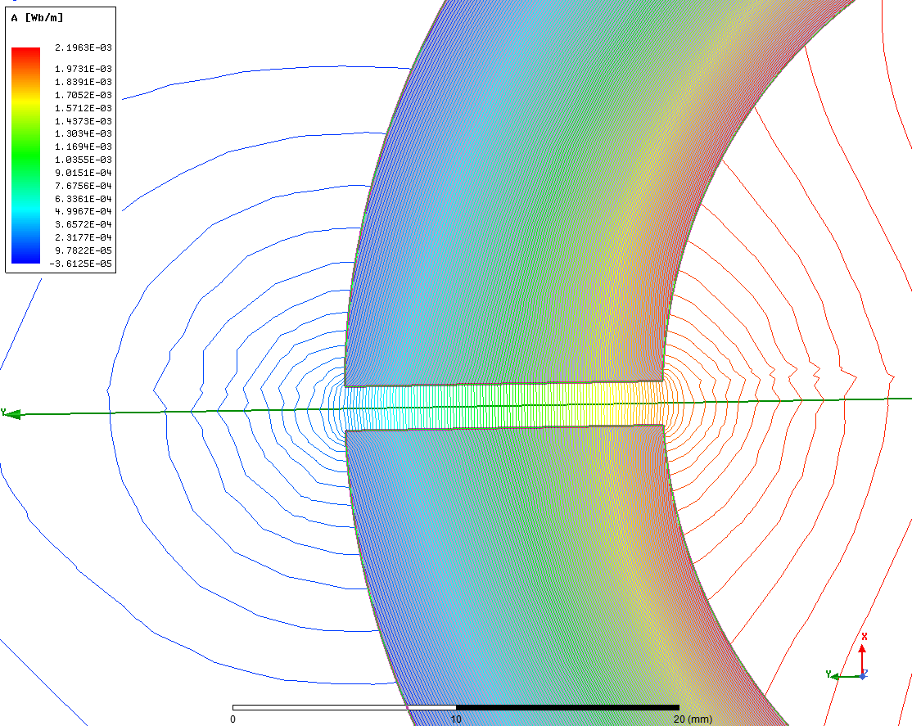

Figure 10: Fringing Flux

Here, flux lines enlarge in the air gap. This flux lines are called fringing flux. Since air has linear BH characteristics, flux lines travels in this way. This phenomenon increases the effective cross section area of the air gap and we observe less reluctance compared to the case of ignoring fringing flux. Now, let’s calculate the inductance in this case.



Figure 11: Inductance Calculation for Gapped Non-linear Case

Here, we have inductance of 0.63 mH. Analytically we obtained 0.53 mH inductance for linear core.

## Discussion

Up to now, we investigated the effect of linearity and homogeneity of the core using analytical and finite element analysis results. Also, we look at the effect of air gap in the inductance. All this results are summarized in Table 3.

Table 3: Comparison of Analytical and FEM Results

|  |  |  |
| --- | --- | --- |
|  | Analytical Result | FEM Result |
| Linear Homogenous Core | 0.91 mH | - |
| Linear Non-homogenous Core | 0.94 mH | 0.95 mH |
| Non-linear Homogenous Core | 0.80 mH | - |
| Non-linear Non-homogenous Core | 0.83 mH | 0.89 mH |
| Linear Gapped Core | 0.53 mH | 0.63 mH |
| Non-linear Gapped Core | - | 0.63 mH |

First of all, we don’t have homogenous core in FEM analysis. Homogenous core logic does not apply to FEM logic. This assumption can be done only in analytical calculations. Comparing cases in non-homogenous case, we observe 1% difference in linear case and 5% difference in non-linear case. This small differences can cause from leakage flux and meshing in FEM. Mesh number and resolution in FEM can affect the results. Also, in non-linear case, we have to import the BH characteristics of the selected core. Maxwell interpolates the given some number of data to obtain BH characteristics. This process can also effect the results. In the gapped core case, we have 15% difference between calculated inductances for analytically and using FEM. In this case, analytically, we tried to model with the method proposed in Mohan and shown in Figure 3. Analytically it is hard to get accurate results when air comes into play. There exists fringing ignored at some portion and also leakage flux creates difference, which is not modelled in analytical case.

Additionally, in FEM case, in gapped core design, linear core and non-linear core have the same inductance. However, in the designs without gap, these two designs have difference inductances. This result is not surprising. When we introduce air gap in the core, operation point in BH characteristics shifted to the left, to linear region. Even if we increase current and introduce non-linearity to the core, we are still in linear region and therefore we have the same inductance value.

Comparing 2D and 3D analysis, in 2D analysis, design is assumed to be cylindrical, for example in our case. In Maxwell, core is assumed to have 1 m of length and all results are given in per meter. However, with this assumption, leakage flux is not modelled in the end parts that is not seen from cross section area. This can make small difference in results. To obtain more realistic results, 3D analysis should be done. The disadvantage of 3D analysis is that it requires more computational power and more time. Much more equations are solved in 3D. To get accurate results, mesh assignment should be done correctly. To save time and computational power, symmetric properties of the design can be used.

# Transformer Design

In this part of the project, single phase transformer is supposed to be designed. For this design, specifications are as follows.

Table 4: Transformer Specifications

|  |  |
| --- | --- |
| **Power Rating** | 500 kVA |
| **Voltage Ratings** | 34.5 kV / 25 kV |
| **Frequency** | 50 Hz |
| **Max. Ambient Temp** | 50 °C |
| **Current Density** | 3 A/mm2 |
| **Fill Factor** | 0.3 |

As a first step in the design, core is selected. Different transformer manufacturers are researched and core with part number M300-35 A from Cogent is selected. It is laminated core and has low core loss. Selected core has following properties.

Table 5: Transformer Core Selection from Cogent

|  |  |
| --- | --- |
| **Part Number** | M300 – 35A |
| **Core Loss** | 2.62 W/kg |
| **Operation Flux Density** | 1.5 T |
| **Magnetic Polarization** | 1440 A/m |
| **Relative Permeability** | 830 |
| **Core Density** | 7.65 kg/dm3 |

Here, core flux density is selected as 1.5 T. In this operation point, core is not saturated but it is in linear region and close to non-linear region. Selection B as large as possible in linear region results in less cross section area and lower cost.

Design procedure is constructed in Excel file and different design sets and their result and performances can be seen from Excel file. The file is in GitHub repo. In following section, general design procedure applied in Excel file is summarized.

* Secondary number of turns are selected as starting point.
* Primary number of turns are calculated.
* Primary and secondary current ratings are calculated. Here, power rating should be used to find secondary side current. However, primary side power will be higher than secondary side power due to losses. Therefore, for now, assuming 95% efficiency and then calculating input power and primary side current will be suitable.
* Now, to find core cross section area, induced voltage equation should be used. Here, we can assume core has square cross section area.

Where X is one edge of core having square cross section area.

* Primary and secondary winding cross section area can be calculated from current density and current rating information.
* Using number of turns, wire cross section area and fill factor, window area can be calculated.
* Assuming square window area, core inner edge length can be calculated easily.
* Now, total length of primary and secondary windings can be calculated. To do this, a mean path length for windings are calculated and multiplied by total number of turns to find total length.
* From total length information for primary and secondary, we can get total copper mass. To do this, wire cross section area also should be taken into account.
* Core dimentions are known. Core mass can also be calculated easily.
* Total mass can be calculated.
* Now, losses can be calculated. First, calculate core losses.

Where, Kcore, is core loss constant defined in W/kg in datasheet and stated in Table 5.

* Primary and secondary windings copper losses can be calculated using total wire length and wire cross section areas. Here, we should also include the effect of temperature here.

Where ρ is resistivity of copper, α is temperature constant, T is operating temperature and Tr is temperature at which ρ is defined.

* Copper losses can be calculated.
* To calculate inductance, we should first calculate reluctance.
* Inductance is calculated as
* To calculate leakage inductances, we should first calculate base impedances for primary and secondary and leakage inductance impedance will be about 2% of this base impedance.

## Results

In transformer design, production cost is important. When we think that designed transformer will be used for 20-30 years, actually, efficiency is more important than the initial cost. Also, transformer has maximum efficiency when core losses are equal to copper losses.

As input, we have freedom to choose secondary number of turns. When we play with this value, we can observe that when secondary number of turns are equal to 1030, core loss and copper losses are equal and we have maximum efficiency, which is 98.88 %. This can be seen in following plot.



Figure 12: Secondary Number of Turns vs. Efficiency

In Figure 12, we can conclude that optimum turns number is 1100 for secondary side. In the core, if we increase core flux density, we can achieve the same results with less cross section area. This means less core losses. However, selected operation point is in linear region and close to non-linear region. Therefore, increasing B further may result in saturated core.

Fill factor is an important parameter. By increasing fill factor, we can decrease window area and therefore we can achieve smaller core and less core losses and more efficient design. However, increasing it too much can cause practical problems.

In the design, we have selected a core with laminations. When we look at the product from the same manufacturer, we can see cores with thinner laminations. This cores have less core losses per weight however they are more expensive than those having thicker laminations. Laminations decreases the core losses but increases cost.

In the end, we have optimum design with following specifications.

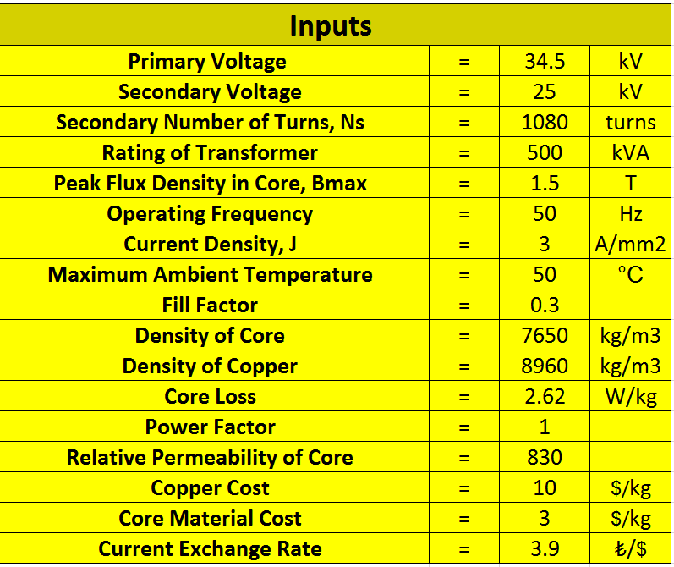

Figure 13: Optimum Design Inputs

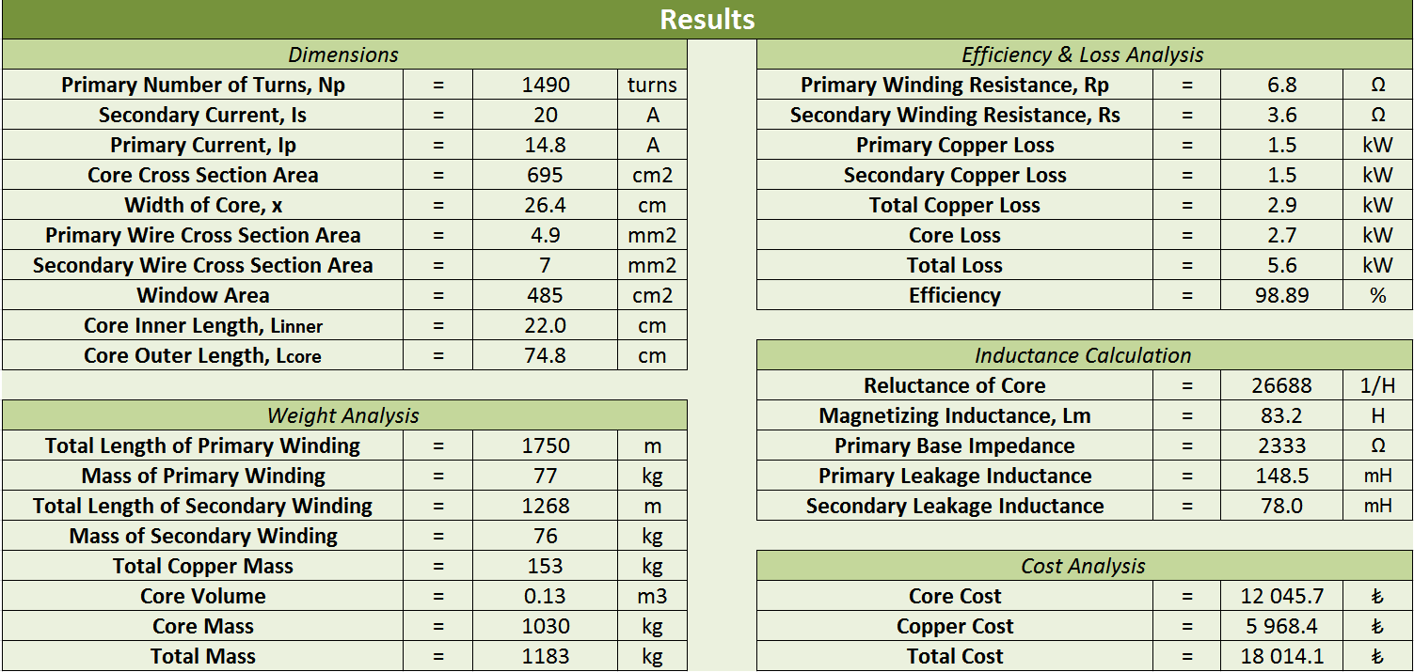

Figure 14: Optimum Design Outputs

The design details can be seen in the Excel file, which is located in GitHub repository.

# Conclusion

In this report, we first designed a toroid inductor. Different properties of the core are investigated. In the results, we observed that homogenous and non-homogenous core types have not much difference in inductance and homogeneity assumption can be made in analytical calculations. However, when we compare the linear and non-linear cores, we see significant difference. In linear core, we had constant permeability and core never saturated. But this case was not practical and has no reality. In non-linear case, which is practical, we have changing permeability with changing excitation. Core starts to saturate when inductor is excited with enough current. This leads to higher reluctance and less inductance. These observations are made in analytical calculations and also they are verified in FEM in Maxwell software. We had very small difference between calculations in analytical and in FEM. This difference is mainly caused from leakage flux, which is ignored in analytical case and meshing in FEM. In further study, we investigated the effect of 2 mm air gap in the core. As we introduce air gap, reluctance is increased and inductance is decreased significantly. In FEM, we also observe fringing flux effect. Effective air gap cross section area is higher when we take fringing flux into account and therefore we have less reluctance in this case.

In second part of the report, we focused on transformer design. Given specifications are analyzed and a laminated core from Cogent is selected. Laminated cores have less core losses but they are expensive compared to cores without lamination. A brief design procedure is introduced in this section and effect of different parameters are interpreted. In optimum design, core losses are equal to copper losses and ın our design, this point are found. All parameters are moved to Excel and a smart designer are created in this software. Variation of efficiency with respect to secondary number of turns are plotted. It is observed that when number of turns in secondary side is 1100, maximum efficiency is achieved. Also, it is verified that in this point, core losses are equal to copper losses. In the optimization process, efficiency is taken as key performance index rather than initial cost. Initial cost is also important but when we think that the transformer will be used to 20-30 years, efficiency will be more important in terms of cost.

In overall, this study was teaching and we learnt how to design an inductor and transformer considering practical issues.

# References

[1] Power Electronics. Converters, Applications and Design (Ned Mohan, Tore M. Undeland, William P. Robbins), p.758, John Wiley and Sons, Inc, 2003.